**TASK 6: Sales Trend Analysis Using Aggregations**

* **Setting-up the Environment in MySql**

**1. Creating a create_table.sql file in the directory where dataset is located**

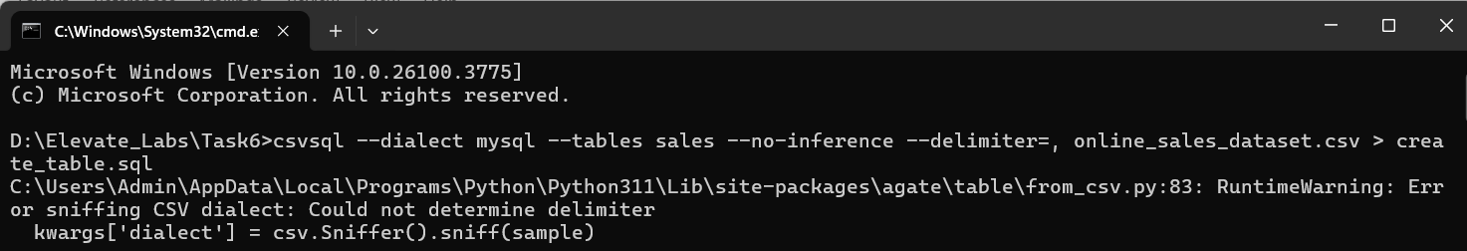

**2. Load the data in the table from dataset**



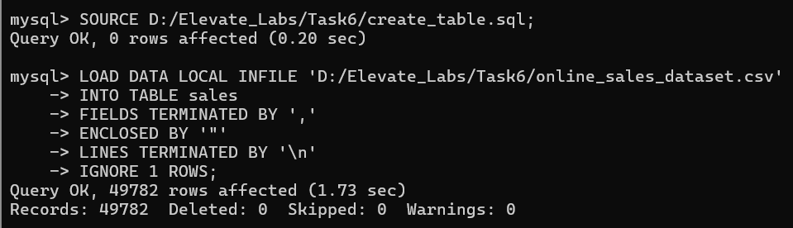

**❖ Start Analyzing the Data**

1. **Show total number of orders**

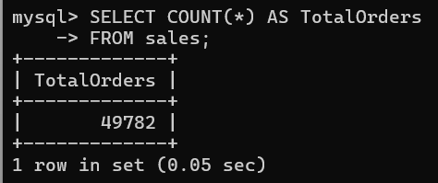

1. **List all unique countries**

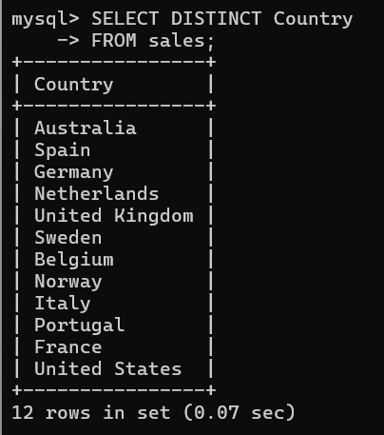

1. **Find top 5 most ordered products**

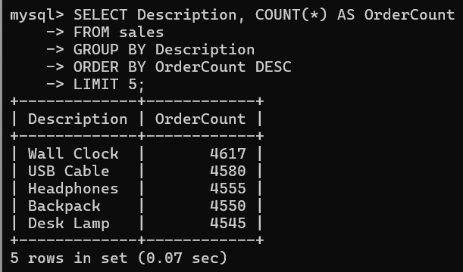

1. **Total quantity sold by product**

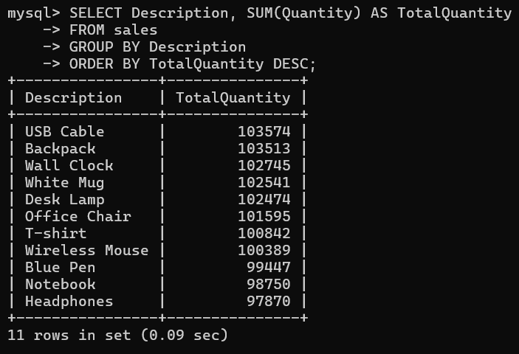

1. **Orders made using each payment method**

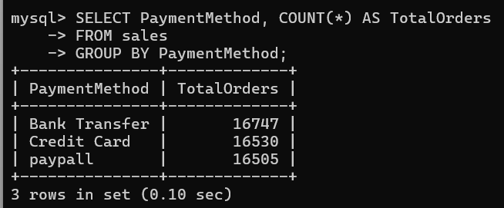

1. **Orders per sales channel**

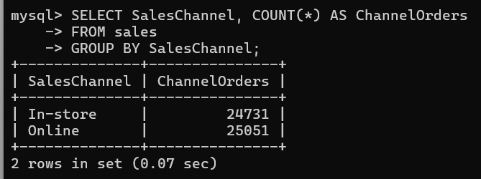

1. **Find orders with discounts applied**

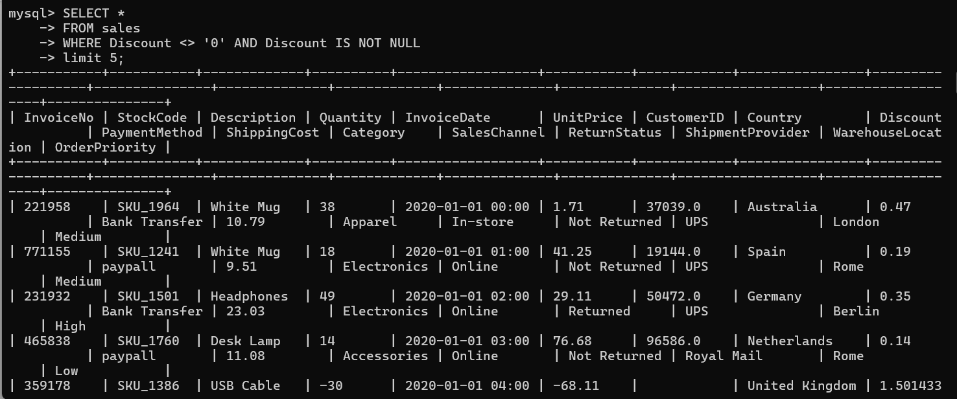

1. **Count of orders per country**

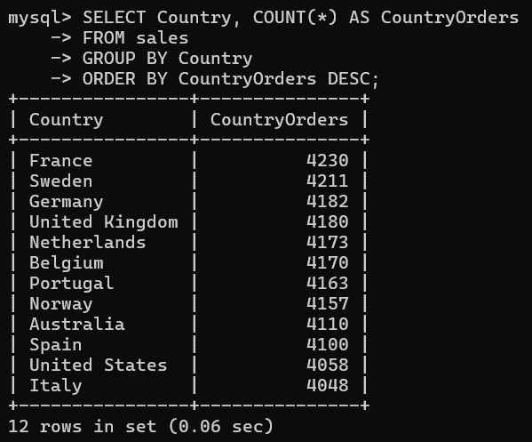

1. **Count of returns vs non-returns**

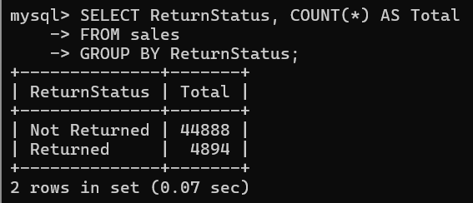

**10. Top 5 warehouses by number of shipments**

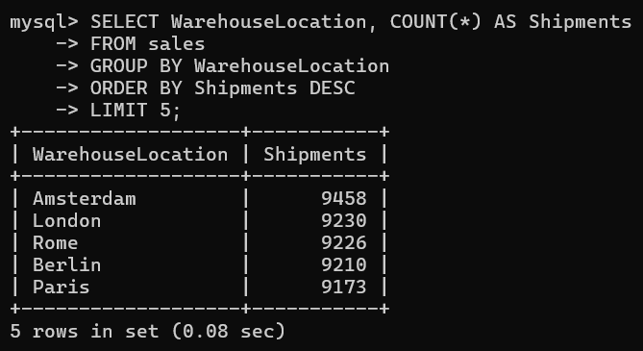

**11. List of orders with high unit price.**

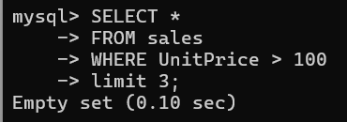

**12. Most common shipping providers**

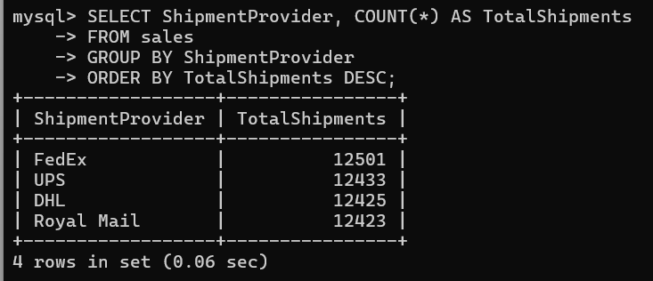

**13. Monthly order count (based on InvoiceDate)**

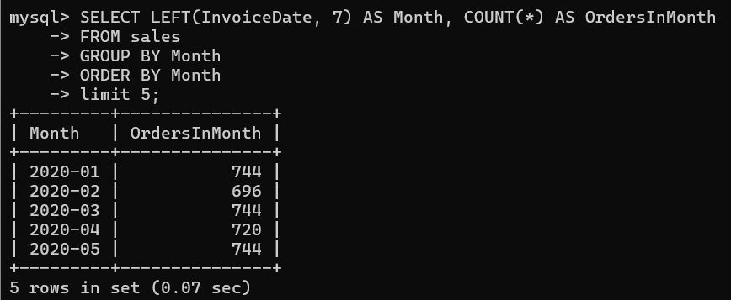

**14. List of high-priority orders**

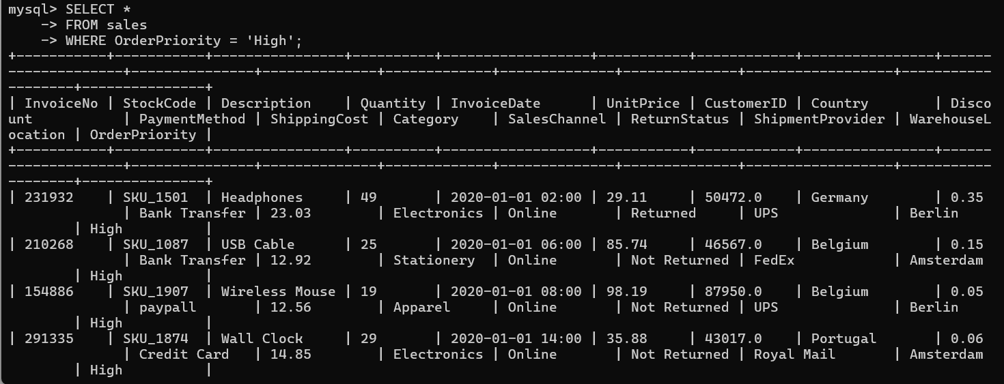

**15. Count of orders per category**

